wLP Website Test Plan

1. Stake Function
Functional Tests:
- Understand the inputs before we make the call to blockchain
- Test only with TP tokens
- See if 10 distributes equally within the token
- Stake minimum allowed amount
  - Failed with 0.00001 due to high network fee
  - 0,001 also failed due to high network fee
Error Paste: RPC request failed:
Request: EthCall(WithOtherFields { inner: TransactionRequest { from: None, to: Some(Call(0xbded0d2bf404bdcba897a74e6657f1f12e5c6fb6)), gas_price: None, max_fee_per_gas: None, max_priority_fee_per_gas: None, max_fee_per_blob_gas: None, gas: None, value: None, input: TransactionInput { input: None, data: Some(0x01ffc9a780ac58cd00000000000000000000000000000000000000000000000000000000) }, nonce: None, chain_id: None, access_list: None, transaction_type: None, blob_versioned_hashes: None, sidecar: None, authorization_list: None }, other: OtherFields {} }, Some(0x21), None, None)
Error: Execution error: execution reverted
eth_call
RPC request failed:
Request: EthCall(WithOtherFields { inner: TransactionRequest { from: None, to: Some(Call(0xbded0d2bf404bdcba897a74e6657f1f12e5c6fb6)), gas_price: None, max_fee_per_gas: None, max_priority_fee_per_gas: None, max_fee_per_blob_gas: None, gas: None, value: None, input: TransactionInput { input: None, data: Some(0x01ffc9a7d9b67a2600000000000000000000000000000000000000000000000000000000) }, nonce: None, chain_id: None, access_list: None, transaction_type: None, blob_versioned_hashes: None, sidecar: None, authorization_list: None }, other: OtherFields {} }, Some(0x21), None, None)
Error: Execution error: execution reverted

- Stake maximum allowed amount
- Stake medium/typical amounts
- Stake with exact wallet balance (100% of holdings)
- Stake multiple times in succession
- Verify staked balance updates correctly
- Verify staking rewards calculation starts correctly
Edge Cases & Validation:
- Attempt to stake 0 or negative amounts
- Attempt to stake more than wallet balance
- Attempt to stake with insufficient gas fees
- Stake with amounts that have many decimal places
- Stake when network is congested (high gas)
- Cancel/reject transaction mid-process
Gas & Fees:
- Verify gas estimation is accurate before confirmation
- Compare estimated vs actual gas used
- Test during different network conditions (low/medium/high gas prices)
- Verify fee display matches blockchain explorer after transaction

2. Unstake Function
Functional Tests:
- Unstake minimum amount
- Unstake maximum staked amount (100%)
- Unstake partial amounts
- Verify cooldown/waiting period if applicable
- Verify unclaimed rewards are handled correctly
- Multiple unstake operations
- Fees for unstaking? It seems very low
- Just generally can we calculate the decimals correctly
- 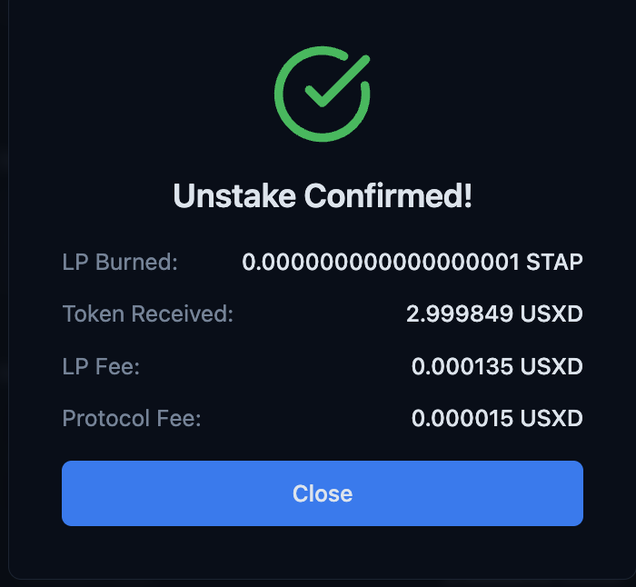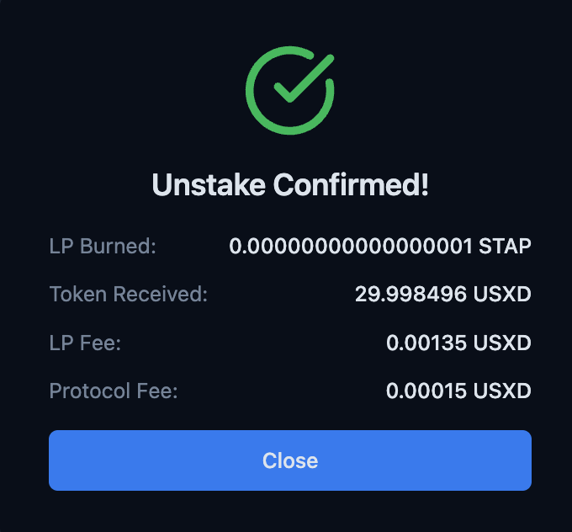
Edge Cases:
- Attempt to unstake more than staked
- Attempt to unstake during cooldown period
- Attempt to unstake 0 amount
- Unstake immediately after staking
- Unstake with pending rewards

3. Swap Function
Functional Tests:
- Swap small amounts (dust amounts)
- Swap large amounts (whale amounts)
  - Failing at max amounts and reasonably lower than max amounts as well
- Swap medium amounts
- Verify slippage calculations
- Verify price impact display
- Verify exchange rates match expected values
- Test with different token pairs
- Attempt swap with insufficient balance

4. Unstake Basket Function
Functional Tests:
- Unstake all items from basket
- Unstake partial basket
- Verify each asset is returned correctly
- Verify basket value calculation

Cross-Functional Tests (Apply to All Functions)

Transaction Flow:
- Transaction confirmation modal displays correct information
- User can reject/cancel before signing
- Pending state shows correctly during processing
- Success state displays correct details
- Failed transactions show appropriate error messages
- Transaction hash is provided and links to block explorer

Wallet Integration:
- Connect wallet functionality
- Disconnect wallet
- Switch wallets mid-session
- Switch networks/chains
- Wallet balance updates after transactions
- Handle wallet disconnection during transaction
- Multiple wallet types (MetaMask, WalletConnect, Coinbase Wallet, etc.)

Error Handling:
- Network errors (timeout, connection loss)
- Insufficient funds messages
- Insufficient gas messages
- Contract revert messages (decode and display user-friendly errors)
- Rejected transactions by user
- RPC failures
- Rate limiting from provider

Gas & Network:
- Gas estimation accuracy (+/- 10% tolerance)
- Different gas priority options (slow/normal/fast)
- Custom gas settings work correctly
- EIP-1559 transactions (base fee + priority fee)
- Legacy transactions if supported
- Network congestion handling
- Failed transaction refunds gas appropriately

Security:
- Contract addresses are correct
- Token approvals requested only when needed
- Approval amounts (unlimited vs exact)
- Revoke approval functionality
- Transaction simulation before execution
- Verify signatures are not reusable
- Check for reentrancy protection

UI/UX:
- Loading states during blockchain queries
- Disabled buttons during pending transactions
- Input validation (real-time feedback)
- Amount formatting (commas, decimals)
- Token balance display updates
- Transaction history/recent transactions
- Copy address/transaction hash functionality

Data Accuracy:
- Compare UI displayed data with blockchain state
- Use block explorer to verify all transactions
- Cross-check balances with wallet directly
- Verify event emissions match UI updates
- Check decimal precision handling (18 decimals)

Test Execution Strategy

Environment:
- Testnet testing (Sepolia, Goerli, Mumbai, etc.)
- Mainnet fork testing
- Production (with small amounts first)

Test Data:
- Multiple test wallets with different balances
- Edge case amounts (1 wei, max uint256, etc.)
- Different token combinations

Automation Considerations:
- Unit tests for utility functions (amount formatting, gas calculations)
- Integration tests with mainnet fork
- E2E tests for critical user flows
- Manual testing for UX and edge cases

Specific Metrics to Track
For each function, track:
- Success Rate: % of successful transactions
- Gas Accuracy: Estimated vs actual gas (should be within 10-15%)
- Transaction Time: From signing to confirmation
- Revert Rate: % of transactions that revert
- User Errors: % of failed attempts due to user input

Security & Attack Testing

Smart Contract Attack Vectors:
- Reentrancy Attacks
  - Attempt to call functions recursively before state updates complete
  - Test if withdrawal functions can be exploited
- Front-Running / MEV Attacks
  - Monitor if large swaps can be front-run for profit
  - Test sandwich attacks (front-run + back-run)
  - Verify if slippage protection prevents this
- Flash Loan Attacks
  - Test if someone can manipulate prices using borrowed funds
  - Verify oracle price manipulation resistance
- Integer Overflow/Underflow
  - Test extreme values (max uint256, etc.)
  - Verify SafeMath or Solidity 0.8+ protections
- Access Control Violations
  - Attempt admin functions from non-admin accounts
  - Try to claim rewards for other users
  - Attempt to unstake other users' funds

Transaction & Signature Attacks:
- Signature Replay Attacks
  - Reuse valid signatures on different chains
  - Replay old valid transactions
- Transaction Malleability
  - Modify transaction data before execution
  - Test nonce manipulation
- Fake Token Attacks
  - Attempt to swap/stake fake tokens with same symbol
  - Verify token contract address validation

Economic Attacks:
- Price Manipulation
  - Large swaps to manipulate pool prices
  - Verify price impact limits work
  - Test oracle manipulation resistance
- Liquidity Draining
  - Attempt to drain liquidity pools
  - Test basket unstake with depleted liquidity
- Reward Gaming
  - Stake/unstake in rapid succession to game rewards
  - Verify cooldown periods prevent exploitation

User Impersonation & Phishing:
- Wallet Connection Exploits
  - Test malicious wallet extensions
  - Verify dApp doesn't request unnecessary permissions
  - Test if someone can connect a wallet they don't own
- Approval Exploits
  - Test unlimited approvals being exploited
  - Verify approval revocation works
  - Test approval for malicious contracts
- Phishing Resistance
  - Verify contract addresses are displayed clearly
  - Test if users can be tricked into signing malicious transactions
  - Verify transaction preview shows accurate data

Data Integrity Attacks:
- State Manipulation
  - Attempt to manipulate blockchain state readings
  - Test if failed transactions can corrupt state
- Oracle Manipulation
  - If using price oracles, test stale price data
  - Test if oracle can be manipulated

Denial of Service (DoS):
- Gas Griefing
  - Attempt to make transactions consume excessive gas
  - Test gas limits on functions
- Block Stuffing
  - Test behavior when transactions can't be mined quickly
  - Verify timeout handling

